**Introduction**

**Design at the heart of professional development**

Every one of you taking this module has the potential to be a great designer. You may already have developed the skills and had experience of designing products. If you have had experience then you will empathise with the following video.

[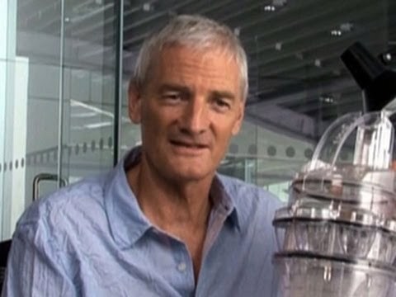](https://www.youtube.com/watch?v=lrHSRhSQw0Y)

In the video, James Dyson explains how he developed, "five thousand failures before he cracked it". This demonstrates the need for perseverance and dedication in order to develop new ideas. If you wish to be a successful designer you will need to develop or enhance these characteristics.

Watch the next video and listen to what Steve Jobs thought about the need for passion when trying to solve hard problems.

[](https://www.youtube.com/watch?v=KuNQgln6TL0)

So assuming you will be the next James Dyson or a Steve Jobs, what should you be doing now? Well, you have made a good choice in coming to the University of Essex. We have designed our degree courses to allow you to gain from our knowledge and experience and will give you plenty of opportunities to use your own creativity to develop the professional skills that companies demand.

### Emerging Technologies Report

The following graph plots expectations against time for the emerging technologies, reported in 2014 by [Gartner](http://www.gartner.com/newsroom/id/2819918).

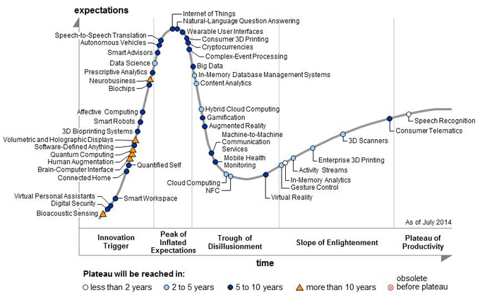

The shape of the curve is well known regarding the emergence of new technologies. Read each title along the curve, identify its position on the timeline, e.g. the "slope of enlightenment", and look it up on the key to find out what the likely time to reach the plateau of productivity.

**Product development**

During this module, you will learn about product development and the project management techniques that can be used to develop a product. The product you are to develop will be stated by me (your customer). I will ask you to develop a piece of software using the Python programming language (Module: CE151-4-AU-CO). More details will be provided in the Week 4 Lecture. For now, just note that through working in teams it is possible to be amazingly creative.

Your Python programming will be used to control a Nao robot.

[](https://www.youtube.com/watch?v=Djzb8c41qbk)

**Time management**

Your level of success at the end of your degree will depend to a great extent on your ability to manage your time effectively. It is very easy to drift for too long and then find it is impossible to get back on schedule. Right from the start of your studies--in other words now--you need to plan your working week. You already have your personal timetable of scheduled events, such as the lectures and laboratory sessions for this module. You can take a look at it here. What about the rest of the week? What other activities should you plan? Self-study? Social time? Earning money? In fact, it is a good idea to plan all your activities. As a guide, the University works on a 1200 hour student working year for a full-time undergraduate student. This means you should be working around 40 hours per week on your studies. How nay timetabled hours do you have? How many private study hours should you therefore schedule? To help you avoid the well-known mistakes watch the following video.

[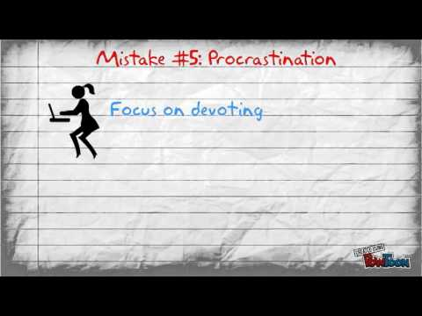](https://www.youtube.com/watch?v=GbJyEBLVuiY)

### Research skills

As well as product development and time management skills there is a host of research skills to be developed while at University. In the first laboratory session, in week 3, you will be guided through a set of tasks to introduce you to the research skills we feel are important. You will firstly learn about maintaining a logbook, which is a form of diary in which you record your plans, your actions against those plans, and finally your reflection on what you achieved against your plans. You will then learn about the classification of research into qualitative and quantitative. If you want to start the process of understanding the differences between qualitative and quantitative research watch the following video.

[](https://www.youtube.com/watch?v=MlU22hTyIs4)